1. What is surprising to me is that on page 641, there’s a $.75 decline in the equity for a change in the stock in either direction. My intuition was that the two directions would result in a decline and an increase. Also, the fact that the expected return of the stock is not included in the pricing formula didn’t make intuitive sense to me. I believe the conclusions reached under so many assumptions, and the part I don’t believe in is its practical applicability to the actual market in that there’s extensive assumptions made that are not realistic in the real world. However, their mathematics seems right.
2. The idea of the paper is that continuous-time markets don’t actually work in continuous time because correlations completely break down, that there’s mechanical arbitrages and that it will create a never-ending arms race. The pictures surprise me in that the market correlations visually resemble each other so much at a frequency of an hour, but when the frequency is adjusted to 1 minute, which is not a small interval, the market correlations already have obvious visualizable differences. We use asymptotic approximation to reach a lot of our conclusions in continuous finance but when dt approaches 0, the theories break down. I don’t think time is really continuous in markets, because even with timestamp, there’s a limit to the unit of time we can use, such as a nanosecond, but we can never truly achieve continuous-time trading.







The results are fairly close to the mean being 0 and the variance being t=5.

I can also say that the more simulations I perform, the closer the results are to 0 and 5 respectively.

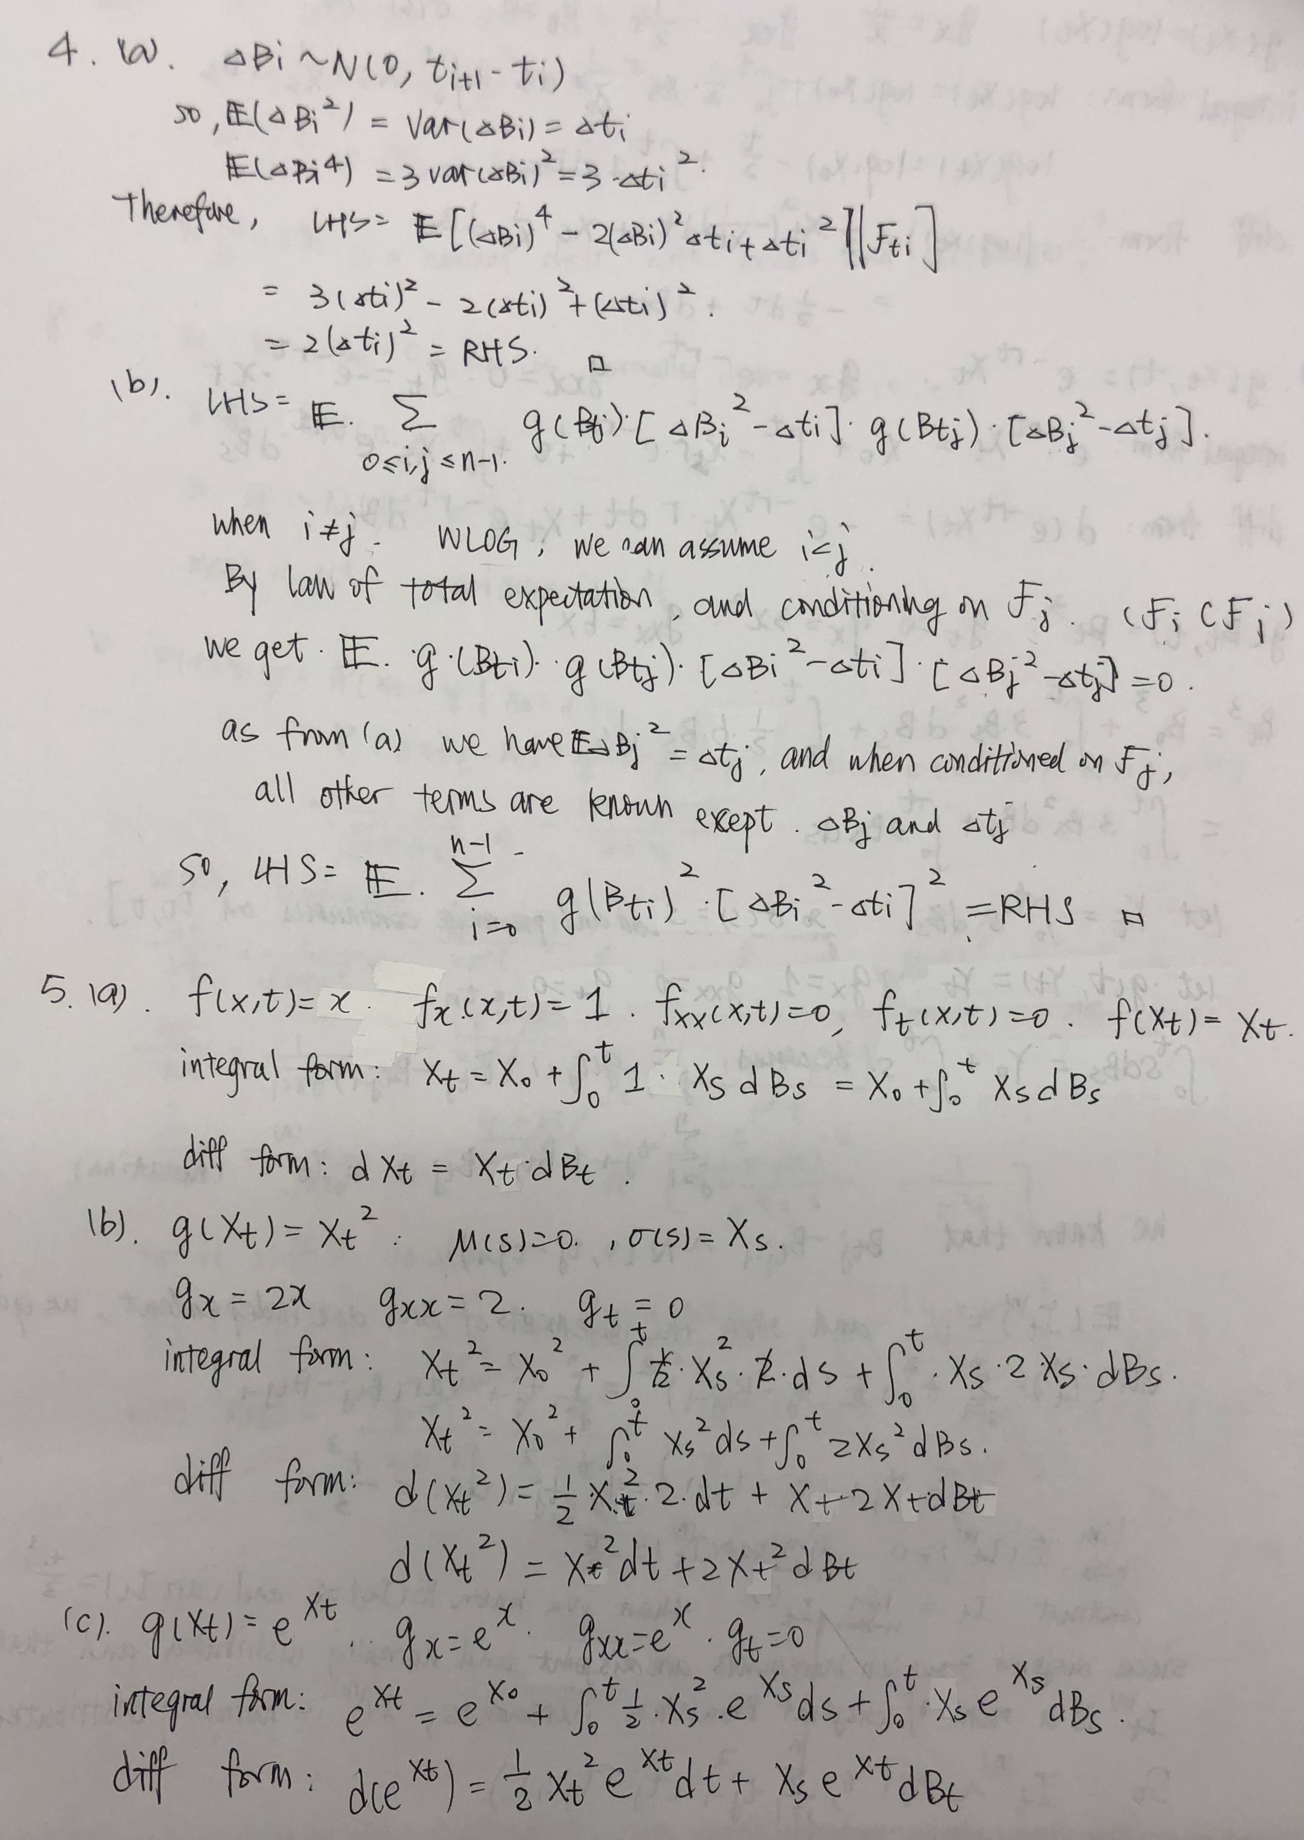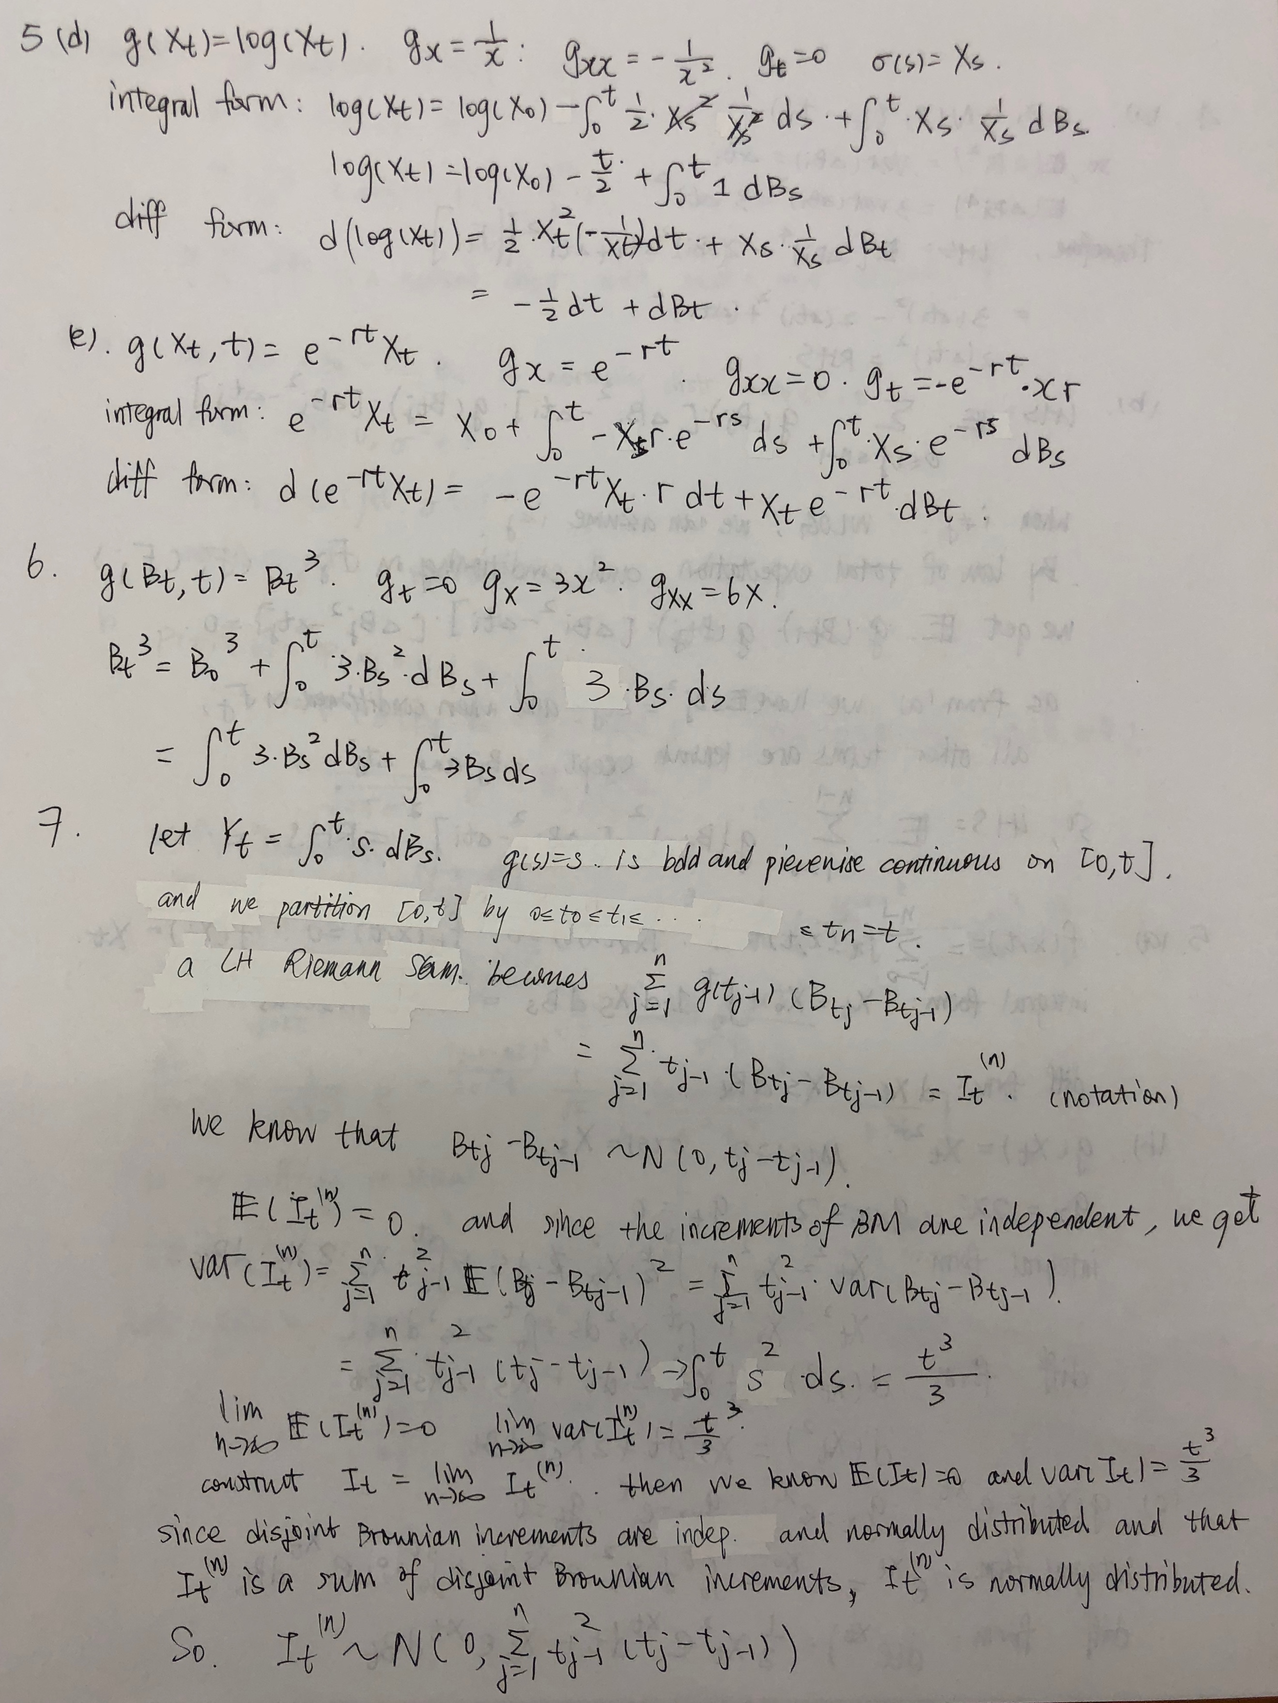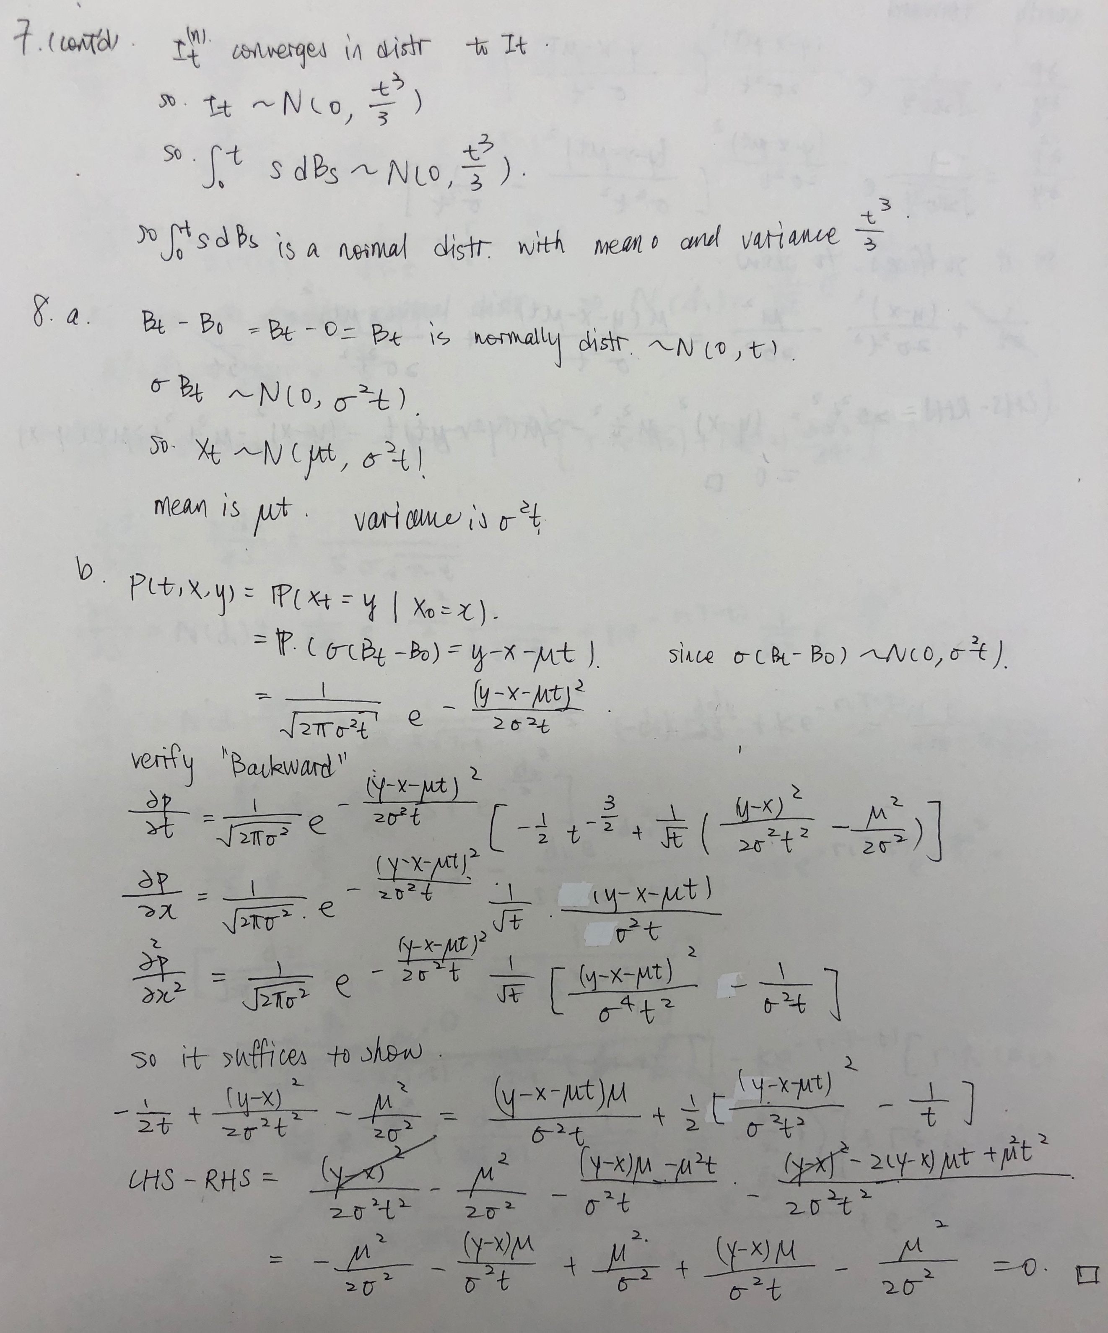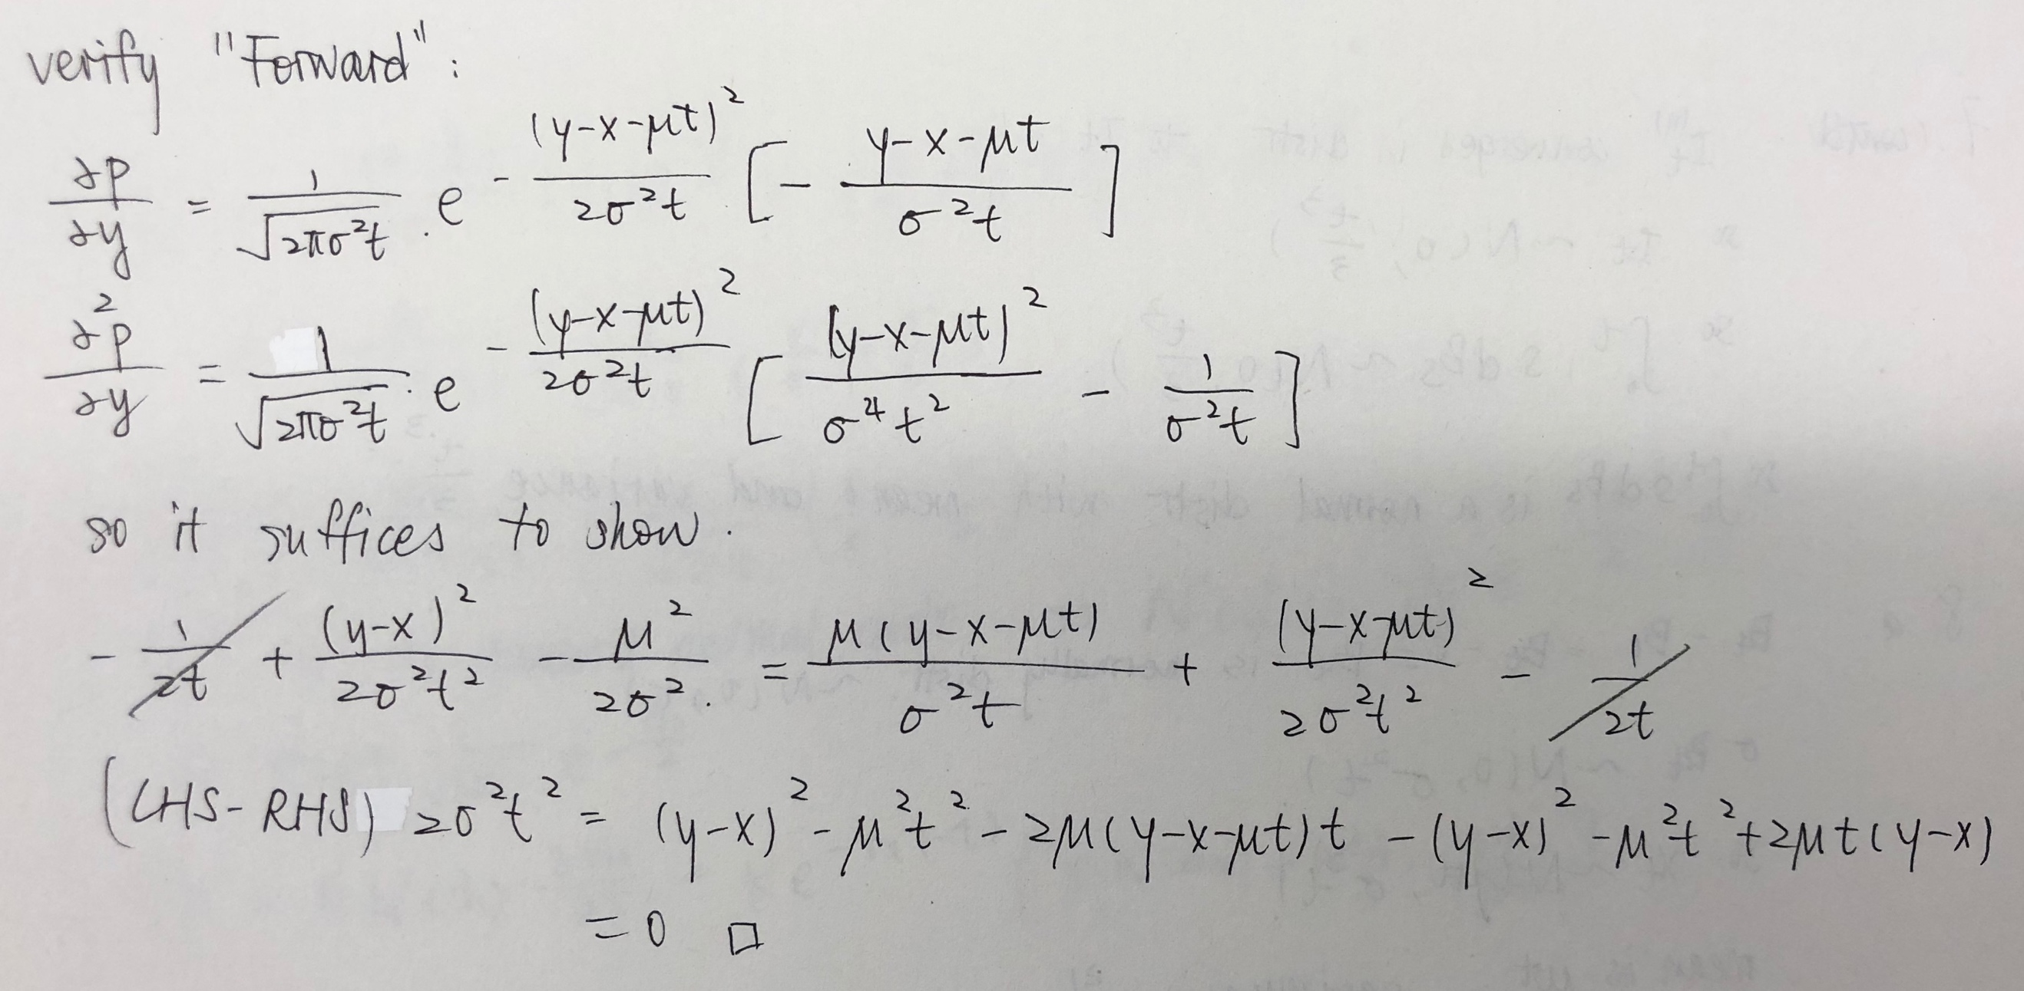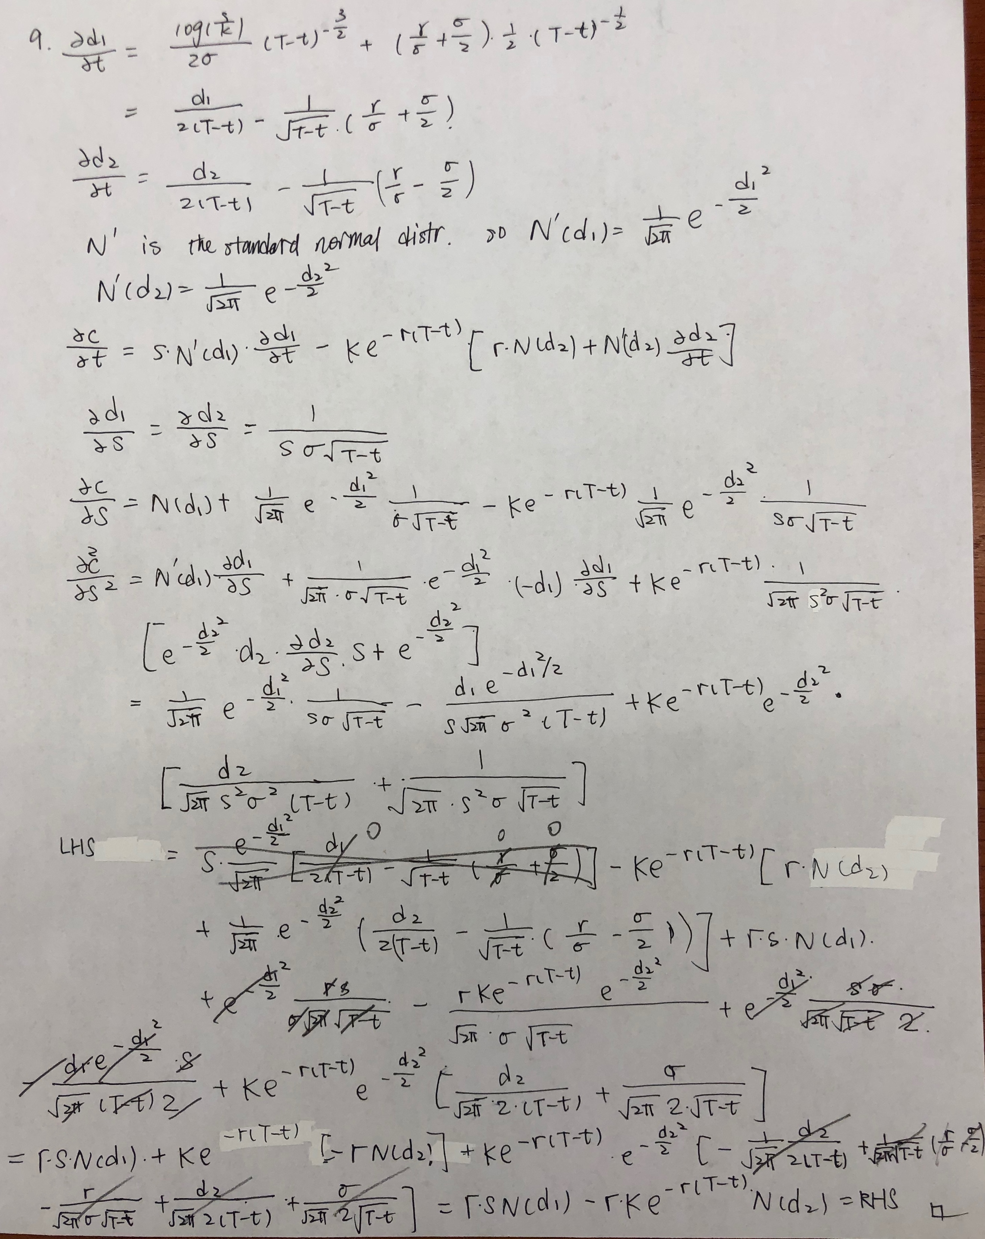

Lisa He